Tutorial 1 – Flash Basics
By Mike ‘muppet’ Cann

Fist have a good layout, I use 2 monitors, I know not all have 2 but this is how I have it setup anyways:

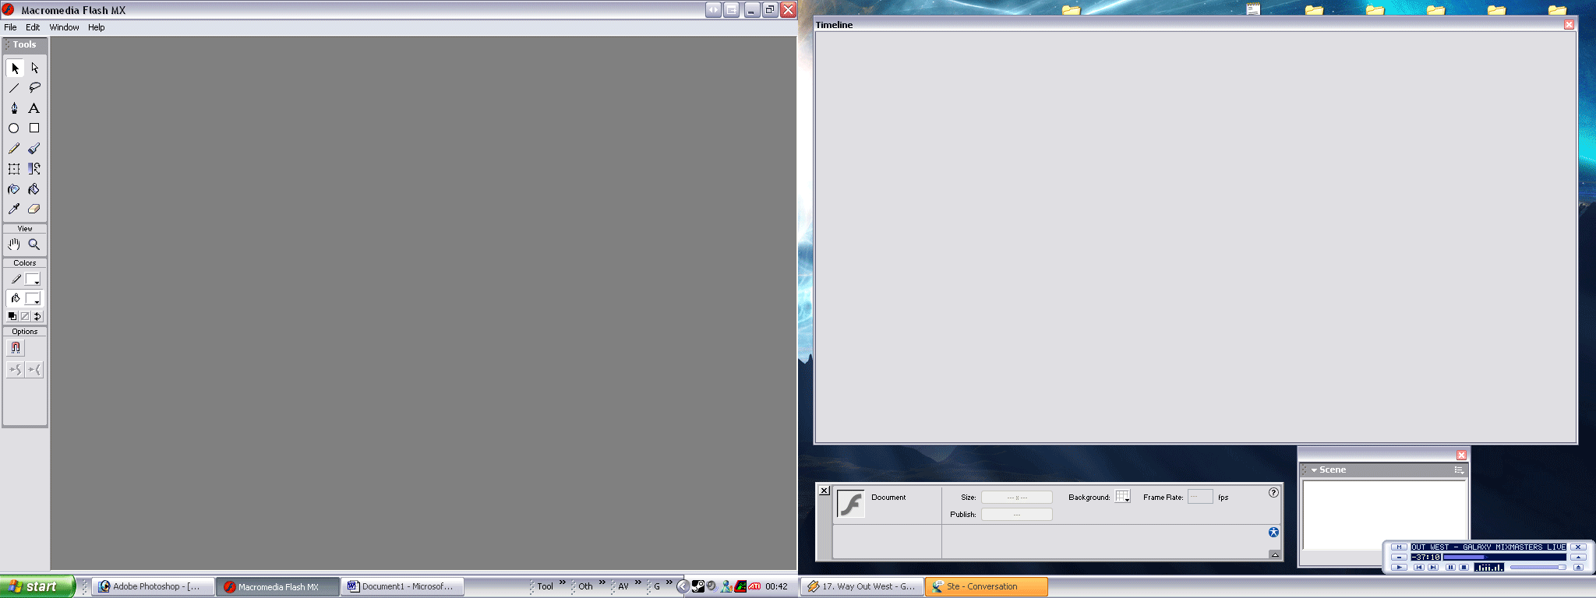

Okay let start by creating a new flash file. Go file > new and you should have a blank canvas. The canvas is a little big at the moment for a sig so lets make it a little smaller. If we go to windows > properties we get this little window opening up:

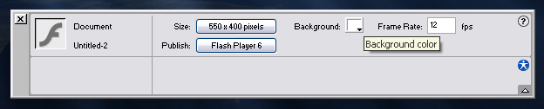

what we need to do is change that size down from 550 x 400 to something more sig size like 350 x 80. Because flash is a vector graphic format however it shouldn’t matter what size you make it as-long as you keep the same proportions you can scale everything up and down at the end!

Also you should note that we can change the FPS and the background colour from this panel, lets change the background colour to match these forums, which happens to be “#505965”. Just type that in the little box and hit enter. Also lets up that FPS a little so the animations will appear smoother, something like 30 fps is nice ☺

Okay so you should now have a canvas that looks something like this:

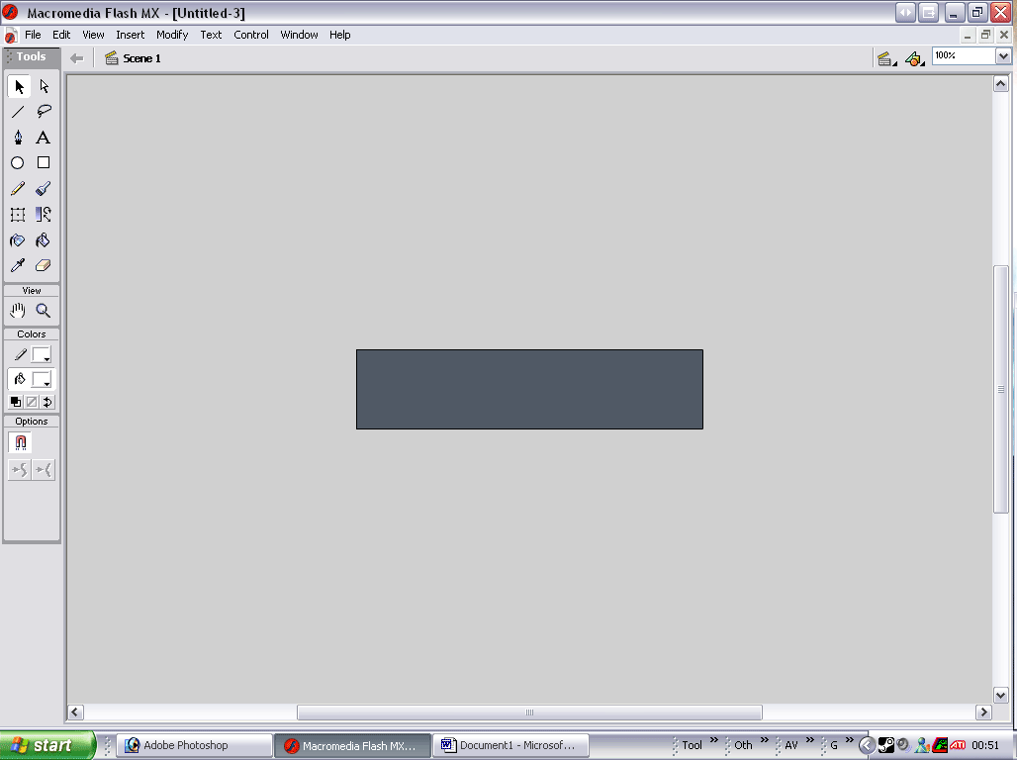

Now lets start creating! First lets create a new layer so we can nicely organise everything that’s going on. On our timeline panel you should notice we already have one layer lets leave that one alone for now and create our own. To do this right click on the layer and select insert new layer:

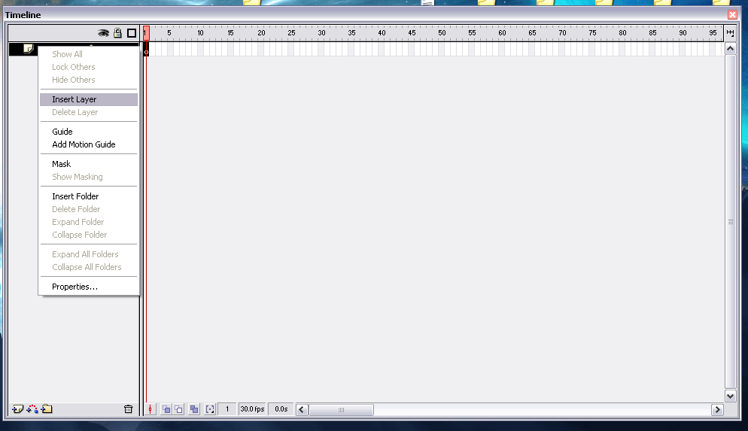

Now we have a new layer called “layer 2”. We are going to use this layer as a temporary layer as you will see in a minute so there is no need to rename it.

Now back in our main window lets create some text for out sig ☺ select the text tool from the toolbar (one that looks like an A) then click in the middle of the canvas and type out your name:

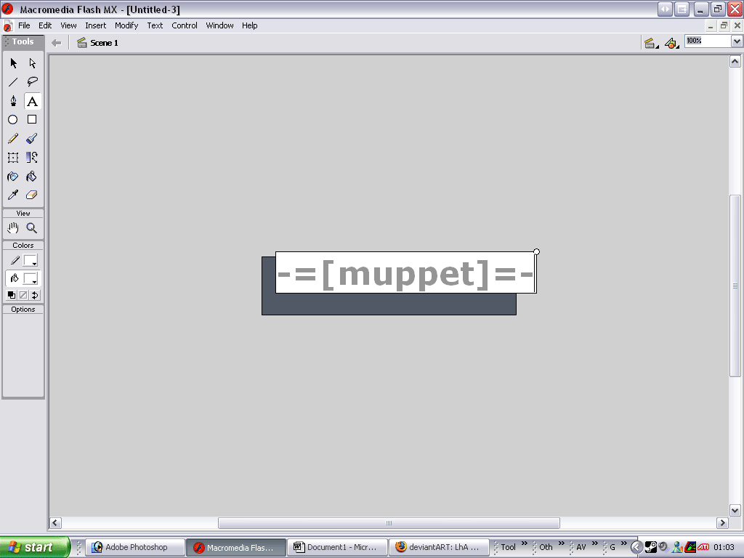

It will look a little different on yours but it doesn’t matter as we are going to change the font and size and stuff using the same properties window we used to change the background colour and FPS.

For the sake of this tutorial im going to use a generic font but you are welcome to use any font you choose. So lets make the text a little smaller and change the colour to white. Also the text looks a little scrunched up so using the character spacing property () lets separate the chars out a little, I think a setting of 2 looks good with this font. You properties panel should now look something like this:

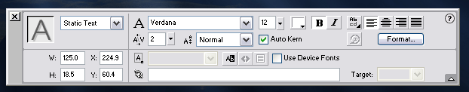

Now going back to the main window move the text so it’s in the bottom right corner of our canvas, and lets zoom in a little so we can see what we are doing if you haven’t already (control & +):

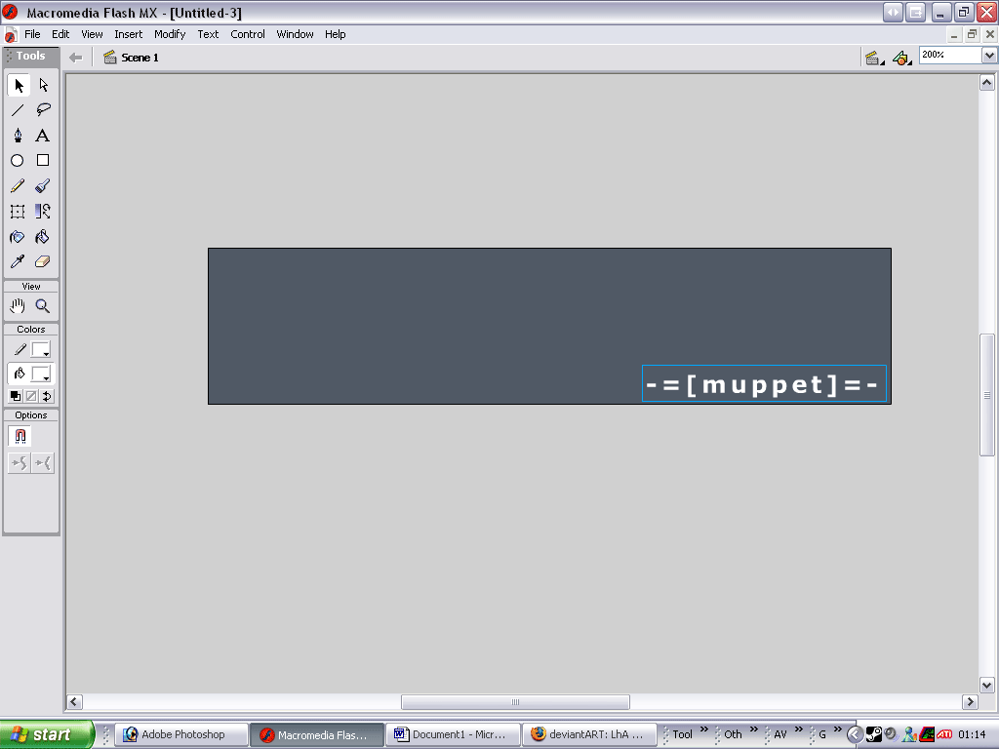

Now to animate the name we have to split the word up into its fundamental components or its letters. To do this we select the word, -=[muppet]=- in my case so it has a blue box around it, as can be seen above. Then right click it and selcect break apart. You should now see lots of little blue box outlines, this kuz the word has been split down into its character components.

Now what we want to do next to better organise things is to put each character on a separate layer. This would be an incredibly tedious and boring task to do it manually (trust me I have done it manually) but thankfully macromedia comes to the rescue with an automated function. To use it simply right click on any of the letters and select “distribute to layers”.

Now you should see that each letter has been given a separate layer and it has been renamed too!

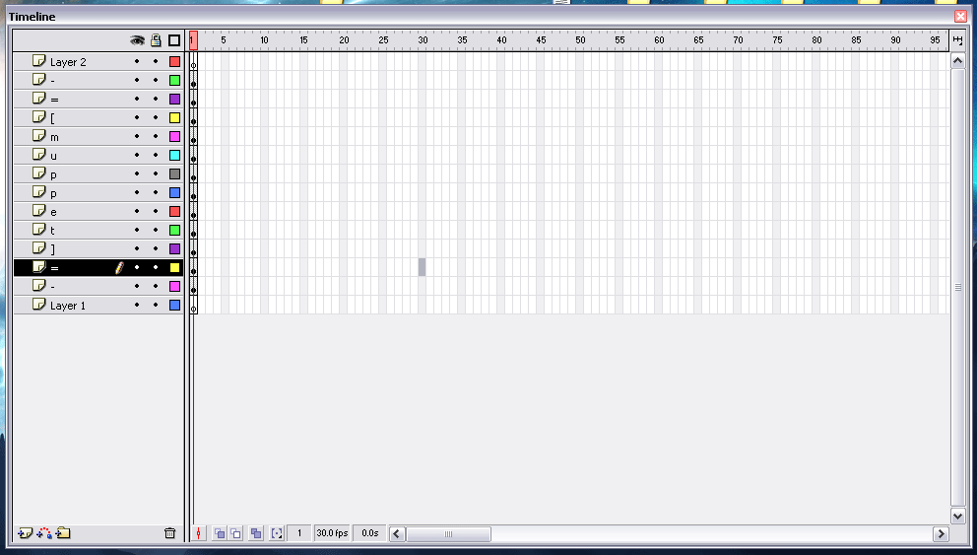

Now to create animation with these characters they need to be converted from simple text to a graphic, that way they can be manipulated as if they were a graphic, that means scaling, tweening, alpha blending etc etc.

To do this we have to select the first character “-“ in my case. You can select in two ways either click on the key frame on the timeline window:

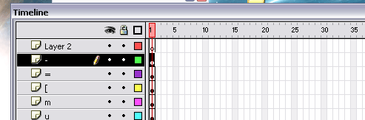

or you can manually select the character from the canvas:



Either way your aim is to have the character “-“ surrounded by a blue box. To convert it to a graphic object we have to go to insert > convert to symbol (shortcut key is F8).

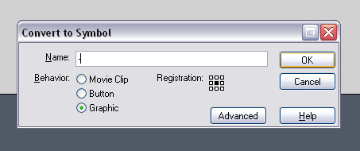

From there select the “graphic” behaviour and rename it to the the name of your character “-“, then click ok.

And now it is a graphics object yey!

Now repeat the process for each character in your name (no simple function for it this time ☹ )

Now for the fun part, animation!

Animation in flash works in much the same way it does in any other program except for the fact it has been made much simpler for your convenience ☺. Animation is made up of frames of still images, when you play those frames in rapid succession you get a smooth animated effect. Don’t worry though you don’t have to create each frame kuz flash uses a system of “key frames” which are basically points where the animation will end or start.

To create a key frame we have to use the timeline window again. Click on frame 25 of your fist character layer, mine is “-“ then hit the F6 key, this creates you a new key frame ☺ Don’t worry that the others have disappeared, its just that they don’t exist at that point of the timeline, we will soon change that. Select the next character down and insert a key frame at about frame 30. Then repeat the process so that each successant frame has a key frame 5 frames later than the previous:

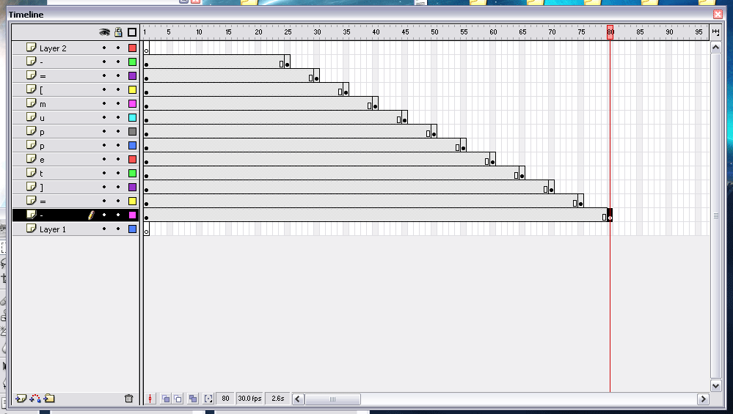

Now we have done that lets see what happens. Select frame 1 on any layer any hit the enter key. You should notice that the letters disappear one by one from the left, this is because as time goes on they are dropping out of existence. To stop this we want to make it so that the letters stick around even after their last key frame.

The simplest way of doing this is selecting a whole column after all the layers have ended and hitting F5 like this:
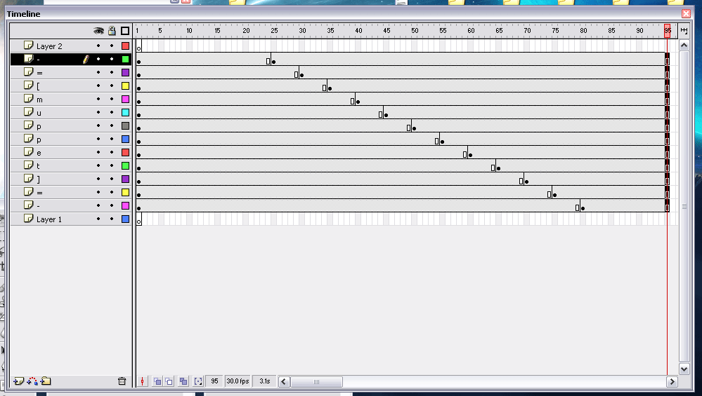

Now running the animation again (click frame 1 then hit enter) you should notice that noting happens! That’s because our characters aren’t doing anything yet, so lets get them moving!

Selecting a column after the end of the last keyframe we should be able to select all the characters at their last keyframe:

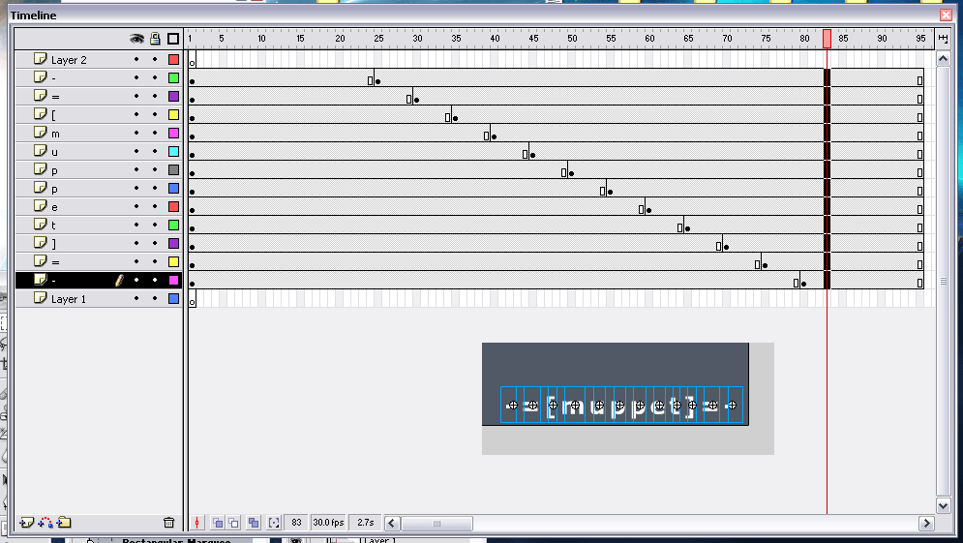

Now with all of those selected move them up to the top of our canvas either by dragging them or by using the arrow keys ( I prefer the arrow keys as I can be assured that they are only moving in the vertical direction then ☺ ) So your canvas should look like this now:

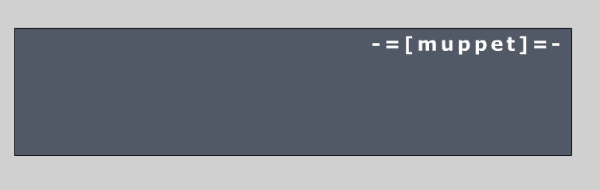

Now run your animation again, and you should notice each letter jumping from the bottom up to the top. As it stands this isn’t a very smooth animation is it? So lets smooth it out using the best feature of flash, tweening!

Select a column on the timeline between the start keyframe and end keyframe like so:

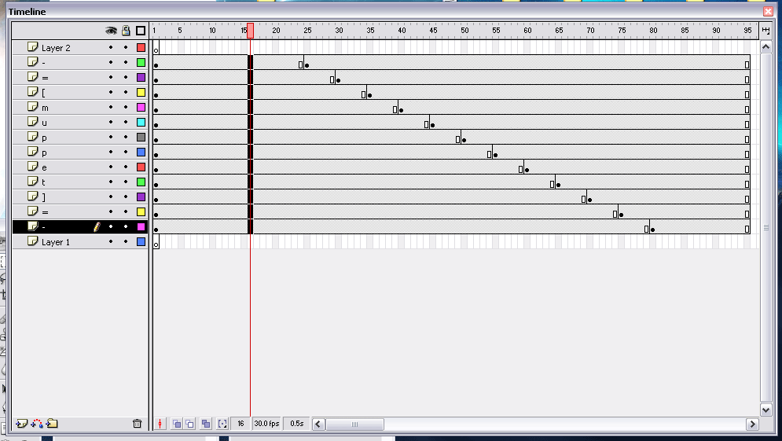

Now using the properties window again where it says “Tween: “ select “motion” from the dropdown. And you should notice that all your frames have gone blue! And an arrow points to the end key frame on each layer, this signifies that a motion tween is in affect on those frames.

Now lets watch our animation! Select frame 1 on any layer of your timeline and hit the enter key. YEYEYEYEYEY! Our letters move up individually!

As good as this looks I think we can do one better by using another nifty function called “easing”.

Select a column again like in the previous screenshot, except this time on the properties dialog change the “easing” value to 100 out (all the way to the top on the slider). Now run your animation again.

Notice how the letters gently arrive at their destination? Nice isn’t it ☺ Now play around see what you can do with the tweening ☺

In the next tutorial I will address alpha blending and colour tinting! Funfunfun.

Muppet

